Mid Term Examination/Quiz
For MSCS: Natural Language Processing (CSEC-720)
For PhD: Special Topics in Natural Language Processing (CSEC-801)

(Time 01:30 hours)
Total Marks: 30 | Course Code: CS-5840

Q1 (a): With respect to logistics regression, derive the cross entropy loss function from single observation x to the whole training set by starting from the following equation p(y|x) = yˆy(1-yˆ)1-y and then finally define the cost function for the whole dataset.
[Hint] Choose the parameters w, b that maximize the log probability of the true y labels in the training data given the observations x. The resulting loss function is the negative log likelihood loss, generally called the cross entropy loss. [5]

Sol:
- Let’s derive this loss function, applied to a single observation x.
  - We’d like to learn weights that maximize the probability of the correct label p(y|x). Since there are only two discrete outcomes (1 or 0), this is a Bernoulli distribution, which can be expressed by probability density function on next slide (keeping in mind that if y=1, Eq. 5.8 simplifies to yˆ; if y=0, Eq. 5.8 simplifies to 1-yˆ):
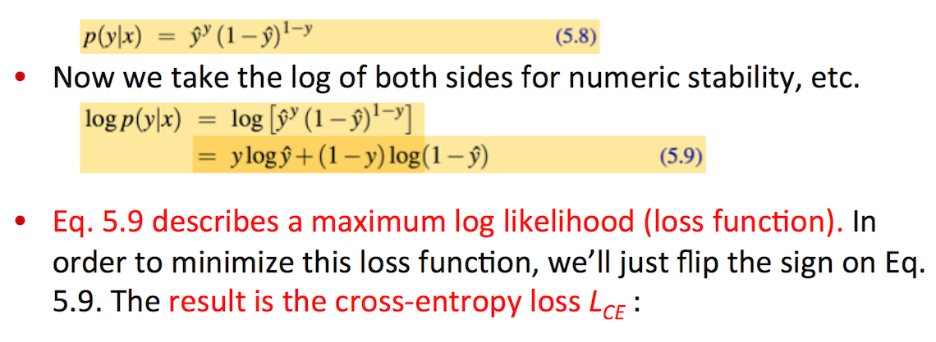
- Now, plug in the definition of yˆ = σ(w·x)+b:
- The negative log of this probability is a convenient loss metric since it goes from 0 (negative log of 1, ‘0’ no loss) to infinity (negative log of 0, infinite loss).
- This loss function also insures that as probability of the correct answer is maximized, the probability of the incorrect answer is minimized; since the two sum to one, any increase in the probability of the correct answer is coming at the expense of the incorrect answer.
- Let’s now extend Eq. 5.10 from one example to the whole training set: assuming x^{(i)} and y^{(i)} mean the i^{th} training features and training label, respectively. We make the assumption that the training examples are independent:
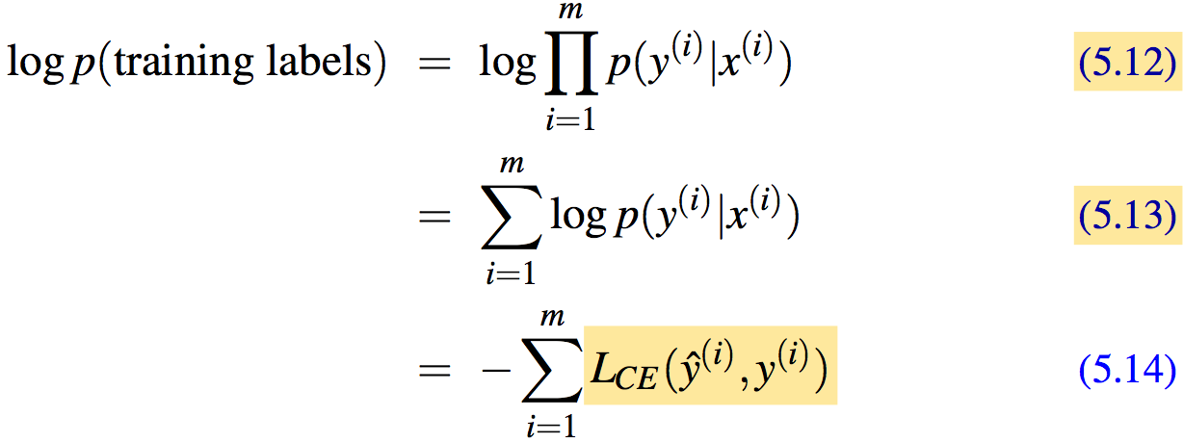
- Cost function for the whole dataset as the average loss for each example:
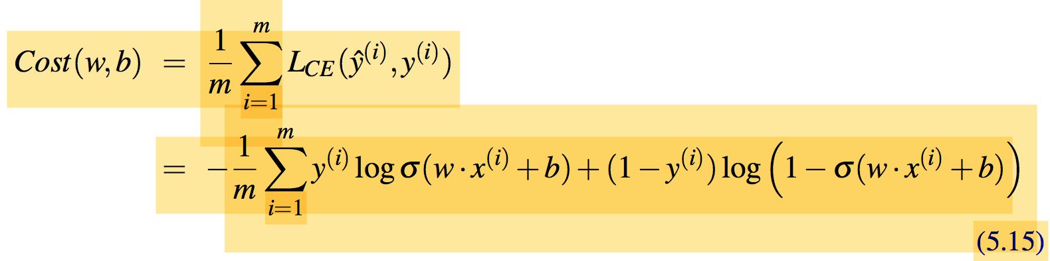

(b): Calculate a single step of the gradient descent algorithm using the following equation θt+1 = θt - η ∇_{θ} L(f (x(i); θ) , y(i)) with initial weights (w₁=w₂ = b = 0), eta (η = 0.1) and y = 1 with only two features: [5]
- x₁ = 3 (count of positive lexicon words)
- x₂ = 2 (count of negative lexicon words)
Sol:
- Let’s walk though a single step of the gradient descent algorithm for a single observation x, whose sentiment value is y = 1 or 0, and with only two features:
  - x1 = 3 (count of positive lexicon words)
  - x2 = 2 (count of negative lexicon words)
- Assume the initial weights and bias in θ⁰ are all set to 0, and the initial learning rate η is 0.1:
  - w1=w2=b = 0 and η = 0.1
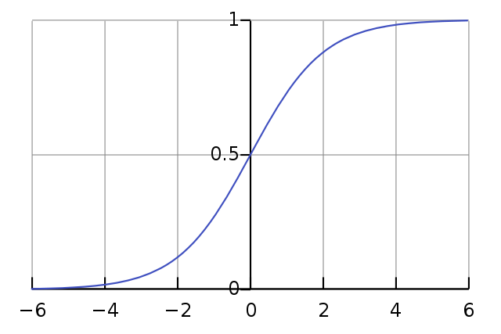
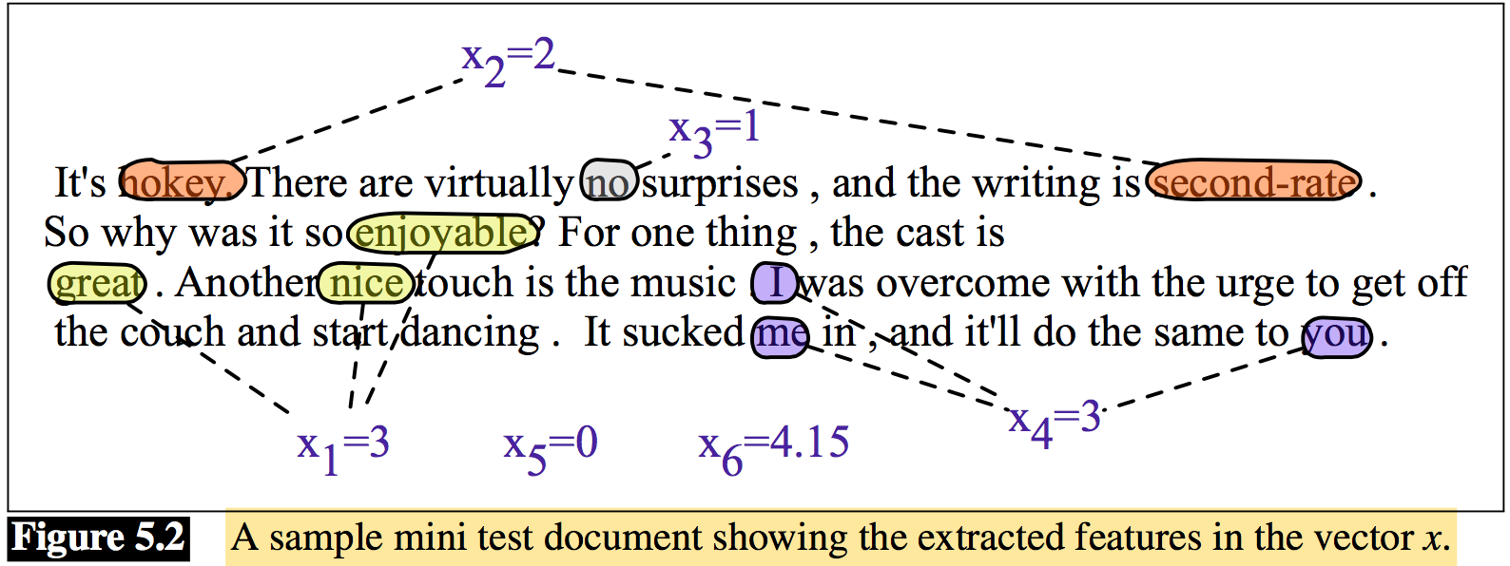
- So after one step of gradient descent, the weights θ¹ have shifted to θ² as:
w1 = .15, w2 =.1,and b=.05

Q2 (a): Consider the following tabular data and calculate the followings. [5]
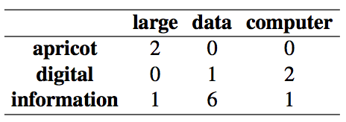
- Provide the equation for Cosine similarity.
- Calculate Cosine similarity for all row pairs and then identify which pairs are more similar than others.
- Draw the graph for visualization of similarity.
Sol:
v_{i} is the count for word v in context i
w_{i} is the count for word w in context i.
Cos(v,w) is the cosine similarity of v and w
- 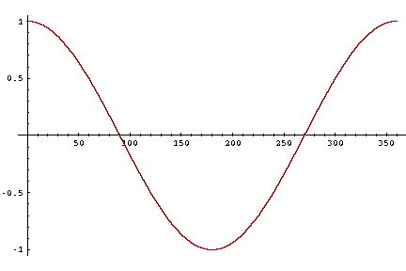
- -1: vectors point in opposite directions
- +1: vectors point in same directions
- 0: vectors are orthogonal (right angle, independent)
- Frequency is non-negative, so cosine range 0-1
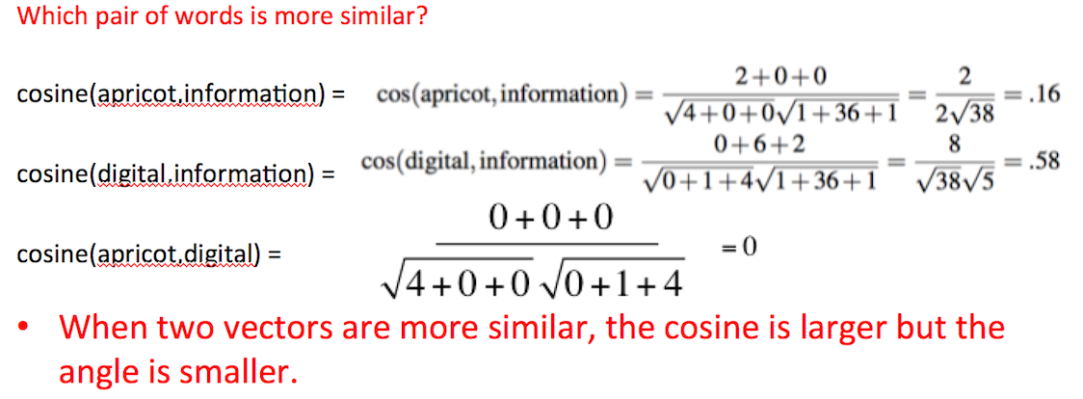
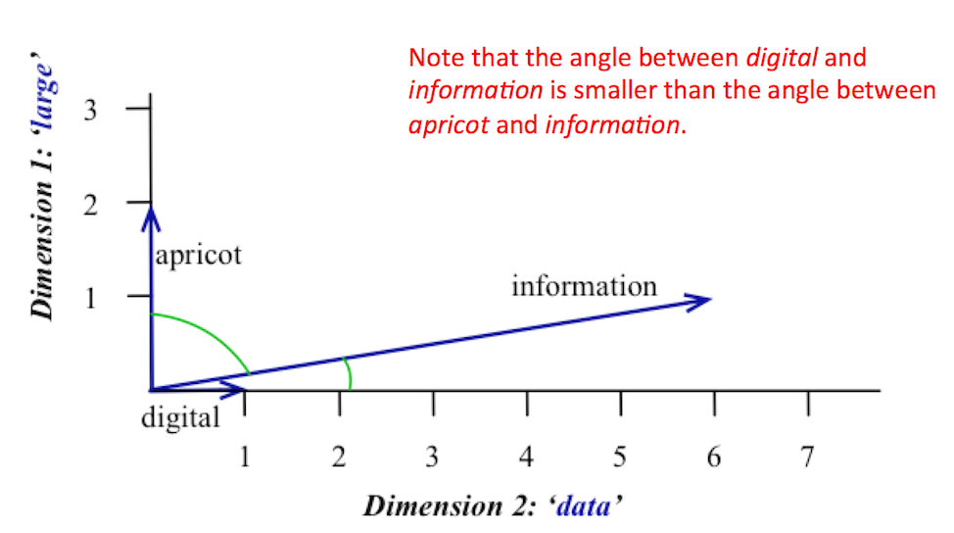

(b): By assuming the embedding size N = 10. Consider the following data and calculate the forward pass for Neural Network based model Word2Vec where X_{k} is the center word (observation word) while Y(c=1) and Y(c=2) are the two context words for the pass #1. [5]
[Hint] Calculate the hidden layer, output layer and softmax while input and output embedding matrices are randomly initialized.

Corpus: Natural language processing and machine learning is fun and exciting

#1 | Natural | language | processing | and | machine | learning | is | fun | and | exciting
#1 | X_{k} | Y(c=1) | Y(c=2)

Weight 1 -W1
0.236 | -0.962 | 0.686 | 0.785 | -0.454 | -0.833 | -0.744 | 0.677 | -0.427 | -0.066
-0.907 | 0.894 | 0.225 | 0.673 | -0.579 | -0.428 | 0.685 | 0.973 | -0.070 | -0.811
-0.576 | 0.658 | -0.582 | -0.112 | 0.662 | 0.051 | -0.401 | -0.921 | -0.158 | 0.529
0.517 | 0.436 | 0.092 | -0.835 | -0.444 | -0.905 | 0.879 | 0.303 | 0.332 | -0.275
0.859 | -0.890 | 0.651 | 0.185 | -0.511 | -0.456 | 0.377 | -0.274 | 0.182 | -0.237
0.368 | -0.867 | -0.301 | -0.222 | 0.630 | 0.808 | 0.088 | -0.902 | -0.450 | -0.408
0.728 | 0.277 | 0.439 | 0.138 | -0.943 | -0.409 | 0.687 | -0.215 | -0.807 | 0.612
0.593 | -0.699 | 0.020 | 0.142 | -0.638 | -0.633 | 0.344 | 0.868 | 0.913 | 0.429
0.447 | -0.810 | -0.061 | -0.495 | 0.794 | -0.064 | -0.817 | -0.408 | -0.286 | 0.149
9 x 10

Weight 2 - W2
-0.868 | -0.406 | -0.288 | -0.016 | -0.560 | 0.179 | 0.099 | 0.438 | -0.551
-0.395 | 0.890 | 0.685 | -0.329 | 0.218 | -0.852 | -0.919 | 0.665 | 0.968
-0.128 | 0.685 | -0.828 | 0.709 | -0.420 | 0.057 | -0.212 | 0.728 | -0.690
0.881 | 0.238 | 0.018 | 0.622 | 0.936 | -0.442 | 0.936 | 0.586 | -0.020
-0.478 | 0.240 | 0.820 | -0.731 | 0.260 | -0.989 | -0.626 | 0.796 | -0.599
0.679 | 0.721 | -0.111 | 0.083 | -0.738 | 0.227 | 0.560 | 0.929 | 0.017
-0.690 | 0.907 | 0.464 | -0.022 | -0.005 | -0.004 | -0.425 | 0.299 | 0.757
-0.054 | 0.397 | -0.017 | -0.563 | -0.551 | 0.465 | -0.596 | -0.413 | -0.395
-0.838 | 0.053 | -0.160 | -0.164 | -0.671 | 0.140 | -0.149 | 0.708 | 0.425
0.096 | -0.995 | -0.313 | 0.881 | -0.402 | -0.631 | -0.660 | 0.184 | 0.487
10 x 9

Sol:
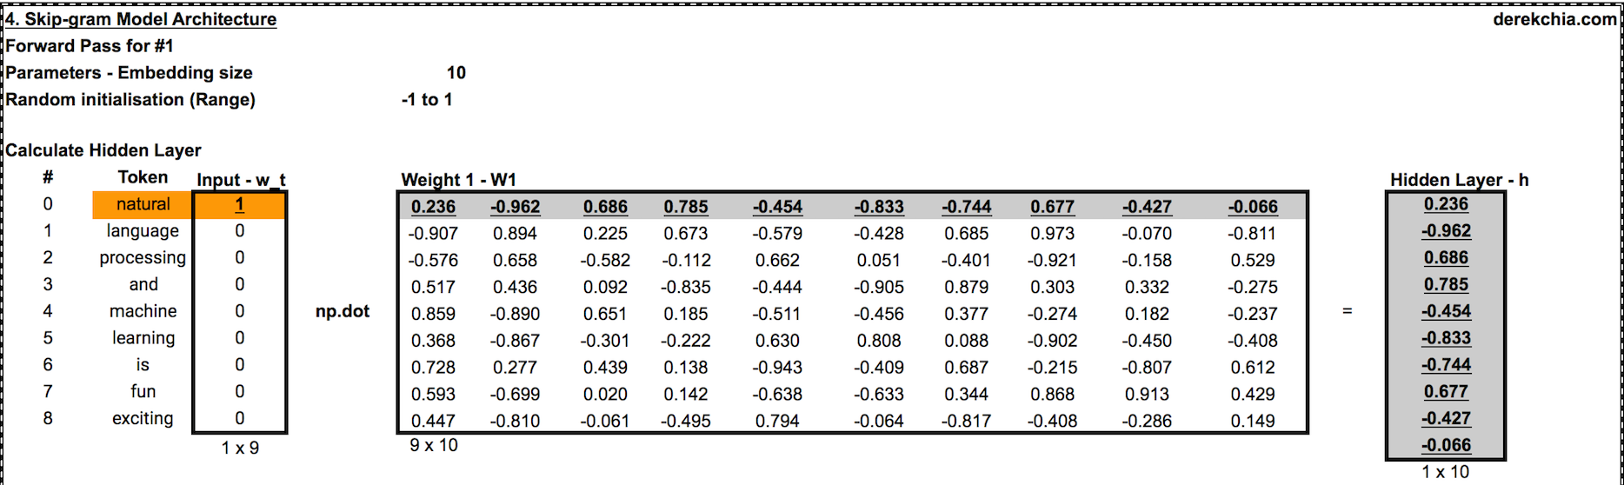
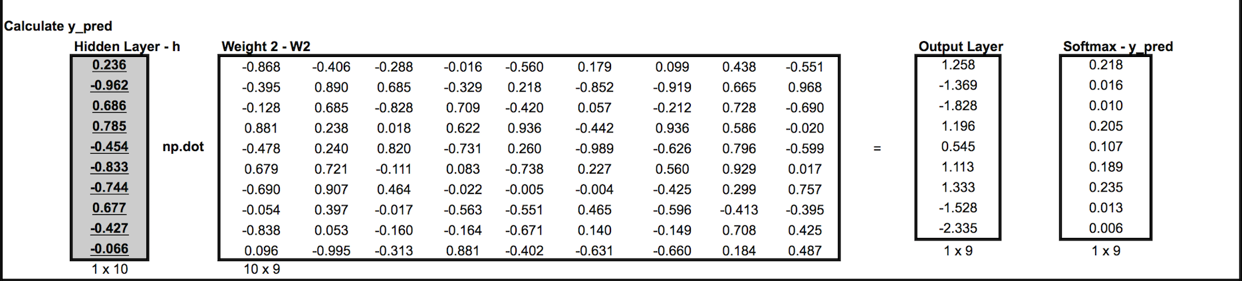
Appendix - Softmax
 |  | Output Layer | Softmax
# | Token | Output Layer | Unnormalized Probabilities |  | Normalized Probabilities
0 | natural | 1.258 | 3.517 |  | 0.218
1 | language | -1.369 | 0.254 |  | 0.016
2 | processing | -1.828 | 0.161 |  | 0.010
3 | and | 1.196 | 3.308 |  | 0.205
4 | machine | 0.545 | 1.724 |  | 0.107
5 | learning | 1.113 | 3.043 |  | 0.189
6 | is | 1.333 | 3.794 |  | 0.235
7 | fun | -1.528 | 0.217 |  | 0.013
8 | exciting | -2.335 | 0.097 |  | 0.006

Q3 (a): Design the algorithm for the following neural language model. [5]
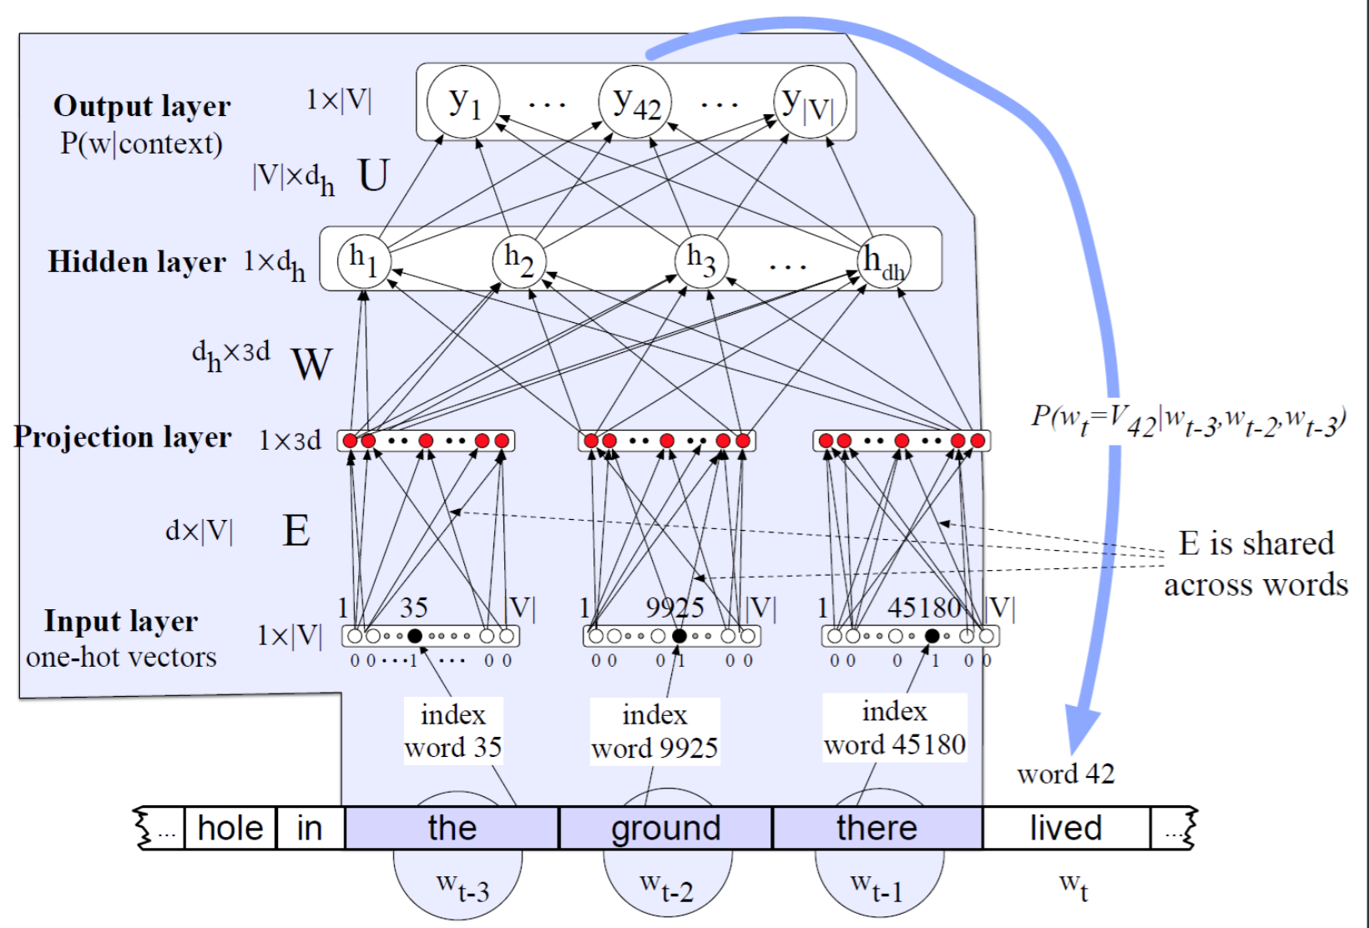
Sol:
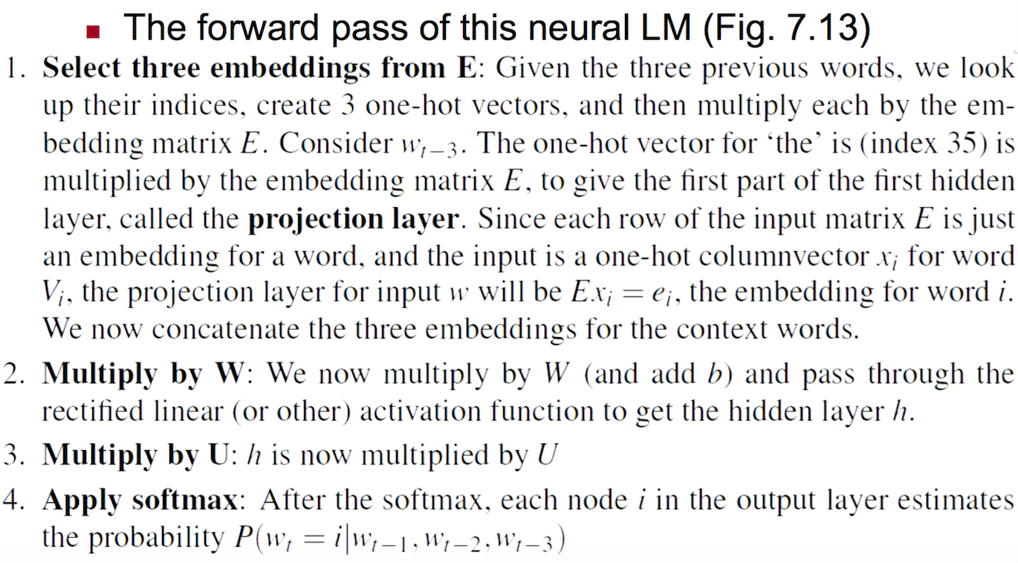

(b): Differentiate the following activation functions w.r.t Neural Network. [5]
- Sigmoid
- Tanh
- ReLU
Sol:
