Quiz # 2 (Take Away Quiz for Regular and Self Support Classes)
Theory of Automata and Formal Languages

Total Marks: 40 | Course Code: CS-3131

Q1: Extract regular expression using the state elimination method from the following DFA.
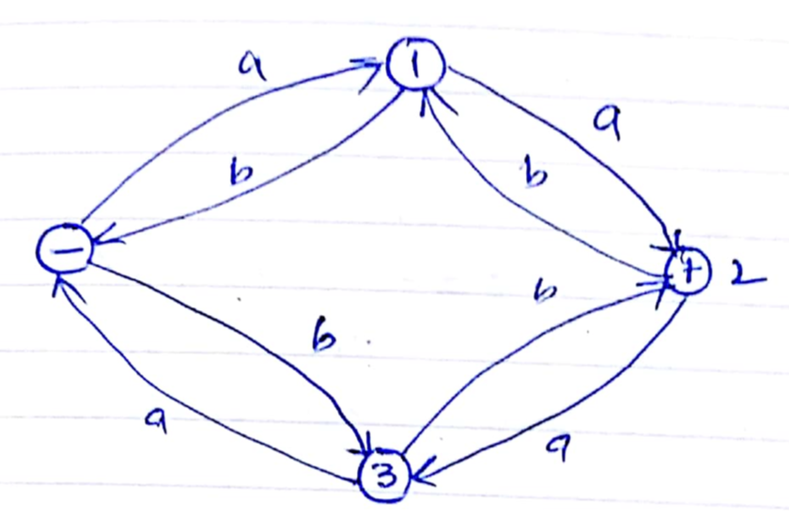

Q2: Using equivalence of states method, minimize the following DFA.
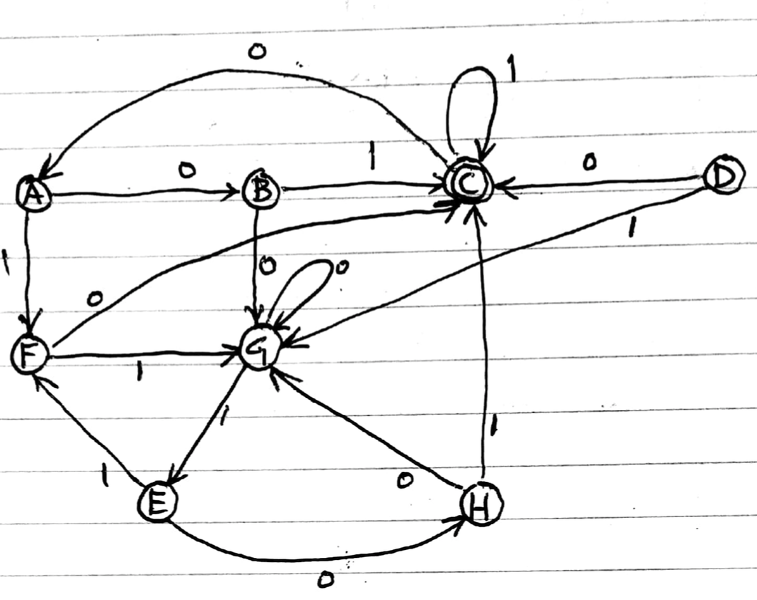

Q3: Design a PDA for the language 0^{n}1^{n}0^{n} .

Q4: Draw a transition diagram for a TM with input alphabet {0, 1} that interprets the input string as the binary representation of a nonnegative integer and adds 1 to it.

